SIMATS ENGINEERING
Department of Information Technology
DSA01 – Object-Oriented Programming with C++

ASSIGNMENT 2 – CO2
Design C++ Programs Using Functions and Object-Oriented Concepts
CO2: Design C++ programs by applying function prototyping, call by reference, return by reference, inline functions, default arguments, function overloading, classes, member functions, access specifiers, arrays within classes, static members, arrays of objects and friend functions.
Student Name | A K Selva Prabhu | Register Number | 192421224
Department / Section | IT | Academic Year / Semester | Nov - Dec 2026
Faculty Name | Amirtha S | Nature of Assignment | Individual
Duration | 1 Week | Total Marks | 50
Date of Submission |  | Date of Evaluation
GitHub Repository | https://github.com/akselvaprabhu/C-plus-plus_192421224/tree/main/Assignments | Compiler | g++ 13.3.0, -std=c++17 -Wall -Wextra

MARK SHEET (Rubric-based Evaluation)
Task | Task Title | Max | Marks Awarded | Remarks
1 | Call Parameters | 6
2 | Return Reference | 4
3 | Defaults & Overloading | 6
4 | SavingsAccount Array | 6
5 | Static & Object Arrays | 7
6 | Friend & Inline | 8
7A | Diagnose Limitation | 2
7B | Design Objective | 2
7C | Revised Solution | 4
7D | Prediction | 1
7E | Validation | 2
7F | Final Defence | 2
 | TOTAL | 50 |  | Percentage:

OVERALL REMARKS

Student Signature | Faculty Signature | Program Director

Q1 – CALL BY VALUE, BY REFERENCE AND BY POINTER (6 MARKS)
The hostel office applies merit (10%), sports (15%) and single-parent (25%) concessions. The key difference between the three functions is whether the function receives a copy or access to the caller's fee variable.
Method | Parameter storage / meaning | Effect on caller
Call by value | A separate local copy of the fee | Caller fee remains unchanged.
Call by reference | An alias for the caller's variable | Updates the caller directly.
Call by pointer | A local pointer stores the caller's address | Dereferencing updates the caller; check for nullptr.

Three implementations
void byValue(long long fee, int percent) {
fee -= fee * percent / 100;
}
void byReference(long long& fee, int percent) {
fee -= fee * percent / 100;
}
void byPointer(long long* fee, int percent) {
if (fee != nullptr)
*fee -= *fee * percent / 100;
}
For an initial fee of Rs.45,000 and a 10% concession, the calculated fee is Rs.40,500. The by-value function changes only its local copy, so the caller still stores Rs.45,000. The reference and pointer versions modify the caller's variable, so it stores Rs.40,500.
Parameter storage and const reference
A value parameter is an independent local object. Changes disappear when the function returns.
A reference parameter is another name for the original variable; no separate fee object is created.
A pointer parameter is a local address variable. The expression *fee accesses the original object.
Use const Student& when a large Student object must be read without copying and must not be modified. For a small long long, pass by value is usually simpler.
Design decision and complexity
For several concessions, returning the updated fee is often clearer because the caller explicitly decides when to store the result. A reference parameter is appropriate when the function's stated purpose is to modify the existing fee. Each implementation takes O(1) time. Copying a long long uses fixed space; copying a large Student object costs space proportional to its size, while reference and const-reference parameters avoid that object copy.

Q1 – PREDICT THE OUTPUT AND COMPLETE THE CODE
Exact predicted output of the supplied program
11 12 13
1 100
16 13 6
Explanation: change(a,b,&c) increments its local copy a from 1 to 11, changes b through a reference from 2 to 12, and changes c through a pointer from 3 to 13. Thus the first line is 11 12 13. bigger(a,c) returns a reference to the larger variable. Since c=13 is larger than a=1, the assignment bigger(a,c)=100 changes c, so the second line is 1 100.
show(1) uses the defaults y=5 and z=10, producing 16. show(1,2) uses the default z=10, producing 13. show(1,2,3) uses all supplied arguments, producing 6.
Completed TODO 1
void applyConcession(long long& fee, int percent) {
fee -= fee * percent / 100;
}
Expected output:
after call by value : 45000
after call by reference: 40500
Call by value leaves the fee at 45000 because the function reduces only its local copy. The reference parameter aliases hostelFee, so the caller's stored value becomes 40500.
Alternative: return the new fee
long long applyConcession(long long fee, int percent) {
return fee - fee * percent / 100;
}
// Caller:
hostelFee = applyConcession(hostelFee, 10);
This return-value version is O(1) time. For a long long, the copied value is small and fixed. For a large Student object, use const Student& for read-only access and Student& only when mutation is required. Never return a reference to a local variable.
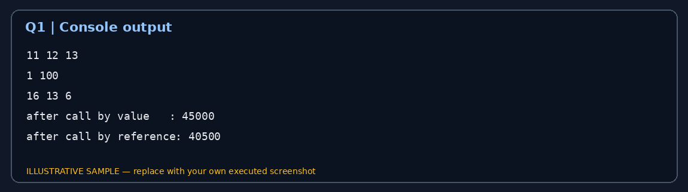

Q2 – RETURN BY REFERENCE AND ITS DANGERS (4 MARKS)
The marks register stores values in an array. Returning a reference to the highest element lets the caller update the actual array element, including by placing the function call on the left side of an assignment.
int& highestMark(int marks[], int n) {
int best = 0;
for (int i = 1; i < n; ++i)
if (marks[i] > marks[best]) best = i;
return marks[best];
}
int marks[] = {78, 91, 84, 88};
highestMark(marks, 4) += 2;
// marks[1] becomes 93
Returning a reference to a local variable is unsafe
int& invalidReference() {
int local = 50;
return local; // dangling reference
}
The local automatic variable is destroyed when the function returns. The returned reference no longer refers to a live object. A compiler commonly warns that a reference to a local variable is returned. Using the reference is undefined behaviour; no output should be relied upon.
Return form | What caller receives | Safety and use
int& | Mutable alias to original element | Can modify original; object must remain alive.
const int& | Read-only alias | Avoids copying, but lifetime must remain valid.
int | Independent copy | Safe after original changes or dies; cannot modify original.

Changed condition: std::vector may grow
When a vector grows beyond its capacity, it may allocate a new memory block and move its elements. This reallocation invalidates references, pointers and iterators to the old elements. A reference retained before growth must not be used afterward.
Alternative: return an index or pointer
int highestIndex(const int a[], int n) {
int best = 0;
for (int i = 1; i < n; ++i)
if (a[i] > a[best]) best = i;
return best;
}
// int i = highestIndex(marks, n);
// marks[i] += 2;
Finding the highest mark is O(n) time and O(1) extra space for reference, index or pointer versions. An index is generally safer with a growing vector because it can be applied again after reallocation, provided the logical ordering has not changed. A pointer or reference may become invalid.

Q3 – DEFAULT ARGUMENTS AND FUNCTION OVERLOADING (6 MARKS)
The original declarations are ambiguous because charge(double) and charge(double,bool=false,bool=false) can both accept a one-argument call. Default arguments do not create separate overloads; they are supplied only after an overload is selected.
Redesigned unambiguous interface
struct Parcel {
double weightKg;
bool express;
bool insured;
};
double charge(double kg, bool express = false,
bool insured = false) {
double total = kg * 40.0;
if (express) total += 50.0;
if (insured) total += 20.0;
return total;
}
double charge(int grams) {
return charge(grams / 1000.0, false, false);
}
double charge(const Parcel& p) {
return charge(p.weightKg, p.express, p.insured);
}
This design uses int for weight in grams, double for kilograms and Parcel for a structured parcel. Only the double overload has default arguments. The rates (Rs.40 per kg, Rs.50 express, Rs.20 insurance) are illustrative because the assignment does not prescribe courier prices.
Six call predictions
Call | Selected overload | Reason
charge(2) | charge(int) | Exact int match; interpreted as grams.
charge(2.0f) | charge(double,...) | float promotes to double.
charge(2.0) | charge(double,...) | Exact double; defaults false,false.
charge(2.0,true) | charge(double,...) | insured defaults to false.
charge(2.0,true,true) | charge(double,...) | All parameters supplied.
charge(Parcel{2.0,true,false}) | charge(const Parcel&) | Exact Parcel type.

How overload resolution works
An exact match is preferred over a promotion or a standard conversion.
A promotion such as float-to-double is generally preferred over a conversion such as int-to-double.
If candidates require equally ranked conversions, the call can be ambiguous.
Default arguments must be specified from the right: after one parameter has a default, all following parameters must also have defaults.

Q3 – ALTERNATIVE CONCEPT AND COMPLEXITY ANALYSIS
Alternative: one Parcel structure with optional fields
struct Parcel {
double weightKg{};
bool express{false};
bool insured{false};
};
double charge(const Parcel& p) {
double total = p.weightKg * 40.0;
if (p.express) total += 50.0;
if (p.insured) total += 20.0;
return total;
}
A single Parcel object makes the options explicit. If a new option such as fragile handling is added, a field and its calculation rule can be added without creating many overload combinations. A function template could generalise input types, but it is unnecessary for this small fixed set.
Aspect | Overloads + defaults | Parcel structure
Selection | Compile-time overload resolution | One ordinary function
Runtime cost | No overload-dispatch runtime cost | One function call
Copied data | const reference avoids copying a Parcel | const reference avoids copying a Parcel
New option | May require more parameters/overloads | Add a field and rule

The charge calculation is O(1) in either design. Overload resolution happens at compile time and adds no runtime cost. Use overloads for a small stable API; use a Parcel structure when optional properties are likely to grow.
Example call sites
double a = charge(750); // 750 grams
double b = charge(2.5); // 2.5 kilograms
double c = charge(Parcel{2.5, true, true});
The function interface should make units clear. In a production program, stronger wrapper types (for example Grams and Kilograms structures) could prevent a caller from accidentally passing a number in the wrong unit.

Q4 – SPECIFYING A CLASS WITH AN ARRAY INSIDE IT (6 MARKS)
Each SavingsAccount object stores its account number, balance, an array of the latest 10 transactions and a count. The array is private so external code cannot corrupt the transaction history or its count.
#include <iostream>
#include <string>
class SavingsAccount {
std::string accountNo;
long long balancePaise;
long long transactions[10];
int count;
public:
SavingsAccount(const std::string& id, long long opening)
: accountNo(id), balancePaise(opening),
transactions{}, count(0) {}
void deposit(long long amount);
bool withdraw(long long amount);
void miniStatement() const;
};
Member functions defined outside the class
void SavingsAccount::deposit(long long amount) {
if (amount <= 0) return;
balancePaise += amount;
if (count < 10) transactions[count++] = amount;
else {
for (int i = 1; i < 10; ++i)
transactions[i-1] = transactions[i];
transactions[9] = amount;
}
}
bool SavingsAccount::withdraw(long long amount) {
if (amount <= 0 || amount > balancePaise) return false;
balancePaise -= amount;
if (count < 10) transactions[count++] = -amount;
else {
for (int i = 1; i < 10; ++i)
transactions[i-1] = transactions[i];
transactions[9] = -amount;
}
return true;
}
The constructor is defined inside the class, while deposit() and withdraw() are defined outside using the scope resolution operator SavingsAccount::. Deposits are stored as positive values and withdrawals as negative values.

Q4 – MINI-STATEMENT, 11TH TRANSACTION AND SCALING
Mini-statement member function
void SavingsAccount::miniStatement() const {
std::cout << "Account: " << accountNo
<< " Balance: " << balancePaise << " paise\\n";
for (int i = 0; i < count; ++i)
std::cout << transactions[i] << '\\n';
}
Design | When the 11th transaction arrives | Append cost
Shift fixed array | Move old entries left; store newest at the end | O(k) moves
Circular buffer | Overwrite oldest slot and advance start index | O(1)
std::deque | pop_front if full, then push_back | Typically O(1) at ends

For a fixed array of capacity 10, shifting moves nine elements each time the full array receives a new transaction. A circular buffer keeps a start index and count. When full, it overwrites the oldest slot and advances start modulo capacity. It uses O(k) storage and O(1) append time.
Circular buffer logic
if (count < CAP) {
data[(start + count) % CAP] = value;
++count;
} else {
data[start] = value;
start = (start + 1) % CAP;
}
For the changed requirement of the last 50 transactions, a circular buffer needs only a capacity change from 10 to 50; its algorithm remains unchanged. A deque provides convenient dynamic storage, while a fixed circular array gives predictable memory and avoids dynamic allocation after construction.
The mini-statement must display logical entries from the oldest retained transaction to the newest. In a circular buffer, physical array order and chronological order may differ, so the display function should access data[(start+i)%CAP].

Q5 – STATIC MEMBERS AND ARRAYS OF OBJECTS (7 MARKS)
The issued-ticket count and capacity belong to the BusTicket class as a whole. Therefore issued and CAPACITY are static. The seat number and passenger name are non-static because each ticket has its own values.
class BusTicket {
static int issued;
static const int CAPACITY = 3;
int seat;
std::string name;
public:
explicit BusTicket(const std::string& n)
: seat(0), name(n) {
if (issued < CAPACITY) seat = ++issued;
}
static int count() { return issued; }
void print() const {
std::cout << name << ": "
<< (seat ? "Seat " + std::to_string(seat)
: std::string("Waiting")) << '\\n';
}
};
int BusTicket::issued = 0;
The static data member is declared inside the class and defined once outside it. A static member function has no this pointer because it is not called for one particular object. It can access static members but cannot directly access non-static seat or name.
Array of objects and expected output
BusTicket trip[4] = {
BusTicket("Asha"), BusTicket("Bala"),
BusTicket("Chitra"), BusTicket("Dev")
};
for (const BusTicket& t : trip) t.print();
std::cout << "Issued: " << BusTicket::count() << '\\n';
Asha: Seat 1
Bala: Seat 2
Chitra: Seat 3
Dev: Waiting
Issued: 3
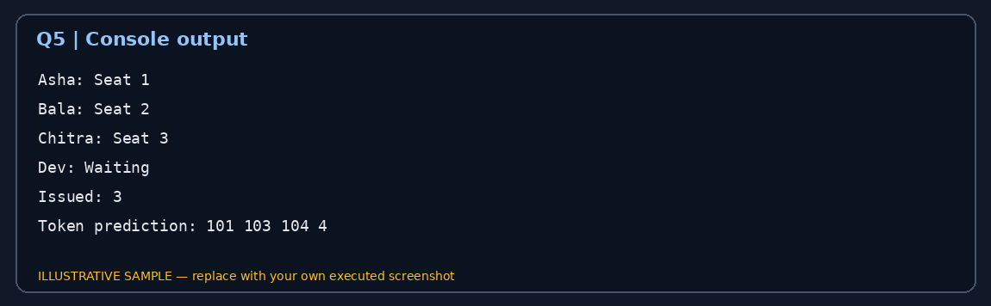

Q5 – STATIC COUNTER LIFETIME AND ALTERNATIVES
In the supplied Token program, Token::next is initialised once to 100. Constructing counter[3] runs the constructor three times, assigning IDs 101, 102 and 103. Constructing extra runs it once more and assigns 104. issued() returns next-100, which is 4.
Exact predicted output
101 103 104 4
The constructor runs four times: once for each of the three array elements and once for extra. The static counter is shared by all Token objects and is not reset when an individual object is destroyed.
Creating tickets inside a function called twice
void createGroup() {
BusTicket group[2] = {
BusTicket("Passenger A"), BusTicket("Passenger B")
};
}
If the function is called twice, the static issued counter continues from its previous value. The local group objects are destroyed when each call ends, but the static counter remains. Under the supplied capacity of three, later objects will be placed on the waiting list once the capacity is reached.
Counter design | Advantages | Limitations
Global variable | One shared O(1) counter | Any code can modify it; weak encapsulation.
Static class member | Encapsulated shared count | One count shared by all objects of that class.
TicketOffice object | Independent counts for independent buses | Office must be passed to ticket creation.

All alternatives update one counter in O(1) time and use O(1) counter space. A static member is suitable for one shared bus. A separate TicketOffice object is better when the college operates multiple buses concurrently because each office can maintain its own capacity and issued count.

Q6 – FRIEND FUNCTIONS AND INLINE FUNCTIONS (8 MARKS)
The journey planner stores hours and minutes privately in a Time class. Friend functions are useful for symmetric operations that compare two Time objects equally.
class Time {
int h, m;
public:
Time(int hh, int mm) : h(hh), m(mm) {}
friend int minutesBetween(const Time& a, const Time& b);
friend bool earlier(const Time& a, const Time& b);
};
int minutesBetween(const Time& a, const Time& b) {
int x = a.h * 60 + a.m;
int y = b.h * 60 + b.m;
return (x > y) ? x-y : y-x;
}
bool earlier(const Time& a, const Time& b) {
if (a.h != b.h) return a.h < b.h;
return a.m < b.m;
}
A friend function is not a member function. It is called as minutesBetween(a,b), not a.minutesBetween(b). It can access private members because the class explicitly grants friendship.
Completed program and expected output
Time departure(9,45), arrival(13,10);
std::cout << minutesBetween(departure, arrival) << ' '
<< std::boolalpha
<< earlier(arrival, departure) << '\\n';
// Output:
205 false
09:45 is 585 minutes after midnight and 13:10 is 790 minutes after midnight. Their absolute difference is 205 minutes. Arrival is not earlier than departure, so the Boolean result is false.
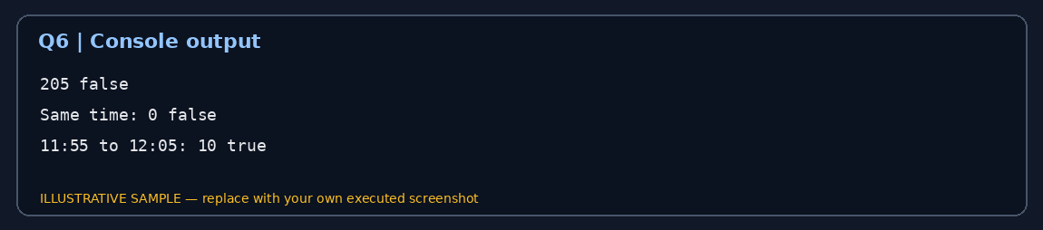

Q6 – CORRECTNESS, INLINE AND DEPLOYMENT DECISION
Test case | Expected result | Reason
09:45 and 13:10 | 205; earlier(09:45,13:10)=true | 585 and 790 minutes.
12:00 and 12:00 | 0; earlier=false | Both times are equal.
11:55 and 12:05 | 10; earlier=true | Correctly crosses noon.
13:10 and 09:45 | 205; earlier=false | First time is later.

What inline actually means
A function defined inside a class definition is implicitly inline in the C++ language sense. The inline specifier permits equivalent definitions in multiple translation units under the One Definition Rule; it does not force the compiler to substitute the function body at every call. The optimiser decides whether inlining is beneficial.
Friend and inline are separate concepts. A friend function may also be declared inline. These small comparison functions are candidates for inlining because they are short and frequently called, but the actual effect must be measured.
Benchmark method for 10,000,000 calls
auto start = std::chrono::steady_clock::now();
for (int i = 0; i < 10000000; ++i)
sink += minutesBetween(a, b);
auto stop = std::chrono::steady_clock::now();
auto ms = std::chrono::duration<double, std::milli>(
stop - start).count();
Compile the same benchmark with -O0 and -O2, repeat several times and record the median. Consume the result (for example, through a volatile sink) so the compiler cannot remove all work. Do not invent timing values: CPU, compiler version and optimisation settings affect measurements.
Friend functions, member functions and getter-based comparisons all take O(1) time. Keep h and m private because public fields would allow invalid times such as 29:90. Retain friend functions if the symmetric comparison is clearest; otherwise member functions or validated const getters are reasonable alternatives.

Q7 – DAY-4 DESIGN CHALLENGE: DIAGNOSE AND REDESIGN (13 MARKS)
Selected program: Q4 SavingsAccount transaction history. The original shifting-array implementation moves k−1 existing elements whenever a new transaction arrives after the array is full. This repeated movement is unnecessary when the requirement is only to retain the latest k transactions.
A. Diagnose the limitation – 2 marks
For capacity 10, each append after the buffer is full shifts nine elements. If the history grows to capacity 50, it shifts 49 elements. The original design is correct but its append work grows linearly with the retained-history capacity.
B. Define a measurable objective – 2 marks
Retain the latest 50 transactions in chronological order, reject invalid transaction amounts, make insertion O(1) regardless of whether the buffer is full, and keep memory fixed and bounded.
C. Design the revised solution – 4 marks
class TransactionHistory {
static constexpr int CAP = 50;
long long data[CAP]{};
int start = 0; // oldest retained entry
int count = 0;
public:
void add(long long value) {
if (count < CAP) {
data[(start + count) % CAP] = value;
++count;
} else {
data[start] = value;
start = (start + 1) % CAP;
}
}
int size() const { return count; }
long long at(int i) const {
return data[(start + i) % CAP];
}
};
The start index identifies the oldest retained transaction. When there is free space, the new value is placed after the newest one. When full, the oldest slot is overwritten and start advances modulo CAP. Logical indexing preserves chronological order.

Q7 – VALIDATION, FINAL DEFENCE AND SUBMISSION CHECKLIST
Redesign pseudocode
ADD_TRANSACTION(value)
IF value is invalid THEN RETURN failure
IF count < CAPACITY THEN
index = (start + count) MOD CAPACITY
data[index] = value
count = count + 1
ELSE
data[start] = value
start = (start + 1) MOD CAPACITY
END IF
END
D. Predict before implementing – 1 mark
Prediction: insertion into a full circular buffer performs one array write and one index update. Therefore insertion remains O(1) when capacity changes from 10 to 50. The memory requirement is 50 × sizeof(long long), plus a few integer fields.
E. Implement and validate – 2 marks
Capacity-5 test input | Expected retained history
Add 10, 20, 30 | 10, 20, 30
Then add 40, 50 | 10, 20, 30, 40, 50
Then add 60 | 20, 30, 40, 50, 60
Then add 70, 80 | 40, 50, 60, 70, 80

For the actual capacity 50, test 49, 50, 51 and 60 insertions. Run both original and redesigned implementations with identical sequences and verify that both retain exactly the same newest 50 values in chronological order. Measure append time with std::chrono for 10,000, 100,000 and 1,000,000 operations.
F. Defend the final design – 2 marks
Criterion | Shifting array | Circular buffer
Append when full | Moves k−1 entries | One write and index update
Memory | O(k), fixed | O(k), fixed
Display | Direct physical order | Use start offset
Trade-off | Simpler code | Slightly more index logic

The circular buffer achieves the objective by eliminating element shifting. It adds index arithmetic and slightly more complex display logic. A shifting array may still be preferable when capacity is tiny and updates are rare. For a frequently updated bank mini-statement, the circular buffer is the stronger design.
Compilation and GitHub submission
g++ -std=c++17 -Wall -Wextra -pedantic q1.cpp -o q1
./q1
DSA01-<RegisterNumber>-Assignment2/
README.md
Q1/ Q2/ Q3/ Q4/ Q5/ Q6/ Q7/
screenshots/ measurements/
Record your name, register number, compiler version, exact compile commands and run steps in README.md.
Keep one folder per question with source code, input files, output screenshots and timing records.
Commit progressively, with at least one commit per task, and submit a working GitHub repository link.
Predictions must be written before execution. Replace illustrative console images with genuine screenshots from your own runs.
Conclusion: Function parameter choices determine whether caller data changes. Returning references is safe only while the referred object remains alive. Overloads must avoid ambiguity. Classes, private arrays, static members and friend functions support distinct design needs. A circular buffer provides bounded memory and constant-time insertion for recent transaction history.

